When we have only one reducer:

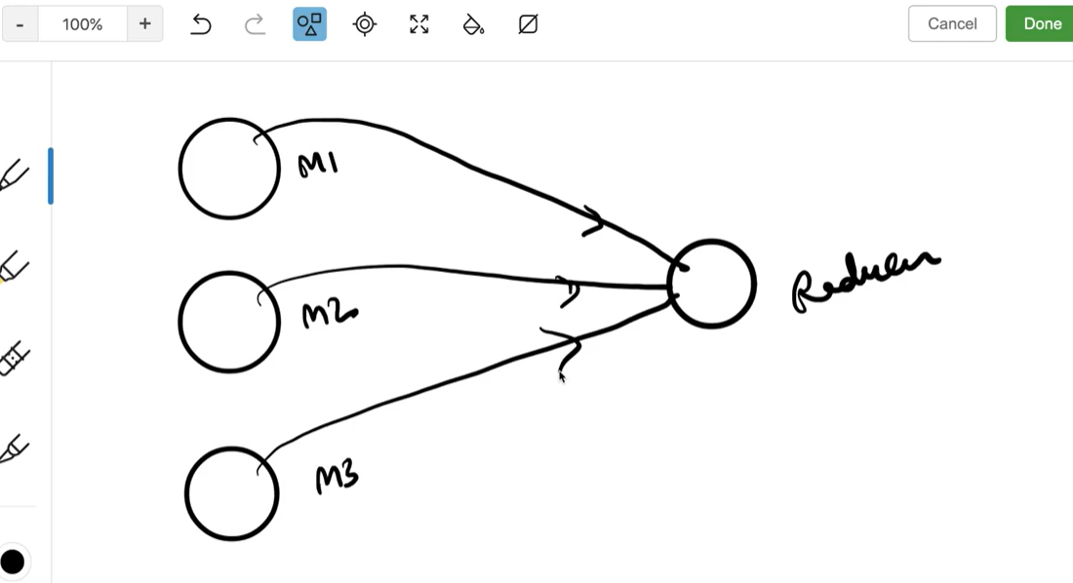
When we have more than one reducer then partition concept will come into picture:
No of partitions per mapper is equal to no of total reducers
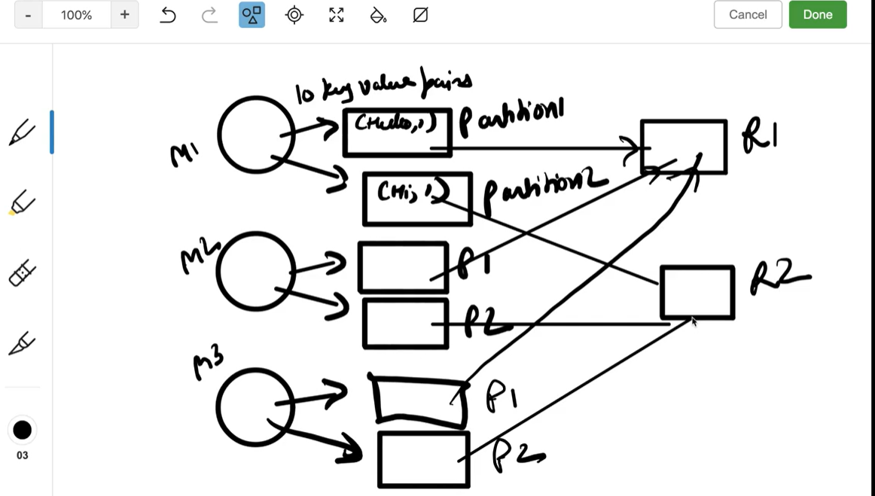

Concept of partition comes into play when we have more than one reducer
This is to tell which key value pair goes to which reducer.
By default there is a hash function (mod) 3 reducers – 0, 1, 2
Let’s say we have key values
1%3 = 1
2%3 = 2
3%3 = 0
4%3 = 1
5%3 = 2 (key 5 goes to reducer called 1)
This hash function is very consistent - meaning same key should goes to same reducer otherwise get different results when reducer does aggregations
(Hello, 1) – Reducer 1
(Hi, 1) – Reducer 2
(Hello, 1) – Reducer 1
But we can also go with custom partitioner logic when we have requirement like convert dollar to rupees (as it changes over the time)
Flow goes like this:
Input data – record reader – mapper – partition – shuffle & sort – reducer
What is sort?
Operation done on reducer machine to get the same keys together in a group.
Values with same keys appear as collection to the reducer.
(Are, {1, 1, 1))
(Hello, {1, 1, 1})

------------ Combiner-------
Local aggregations as we are introducing combiner at the mapper side.
Improve parallelism
Reduce data shuffling from mapper to reducer – we are only sending 4 rows to reducer instead 6
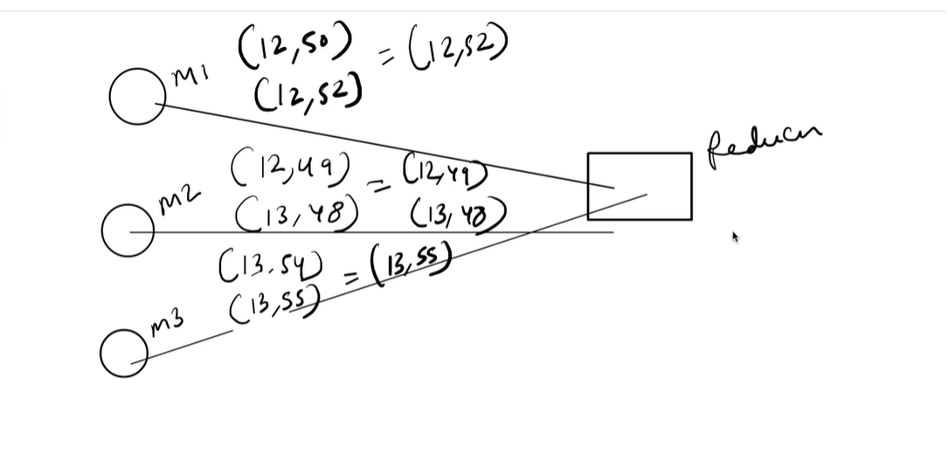
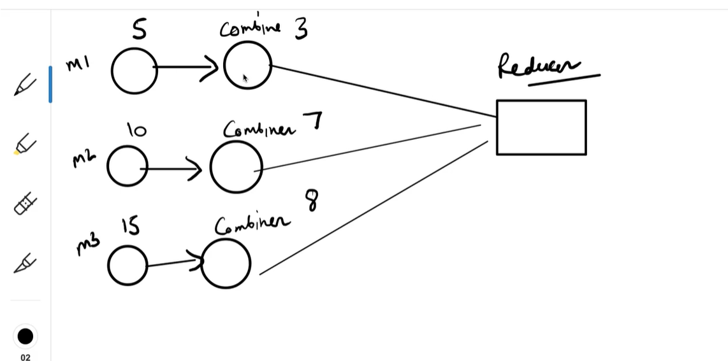

Reducer works on the entire data but combiner works only on the mapper data
Use combiners with caution
W/o combiner get max
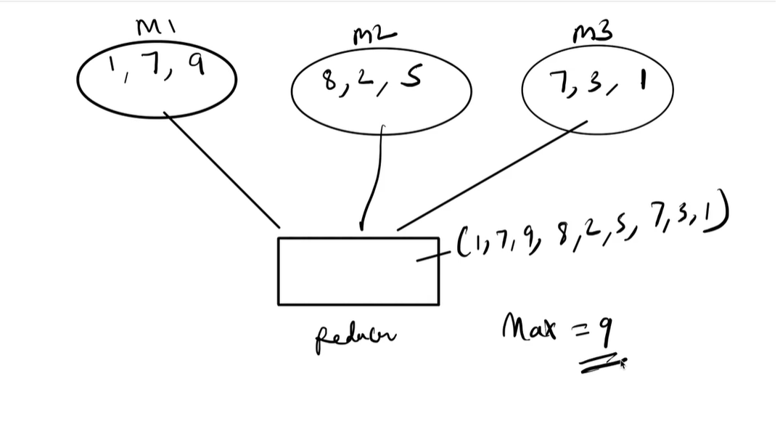
And if we use combiner (local aggregation) and try to get a max our result would be same.
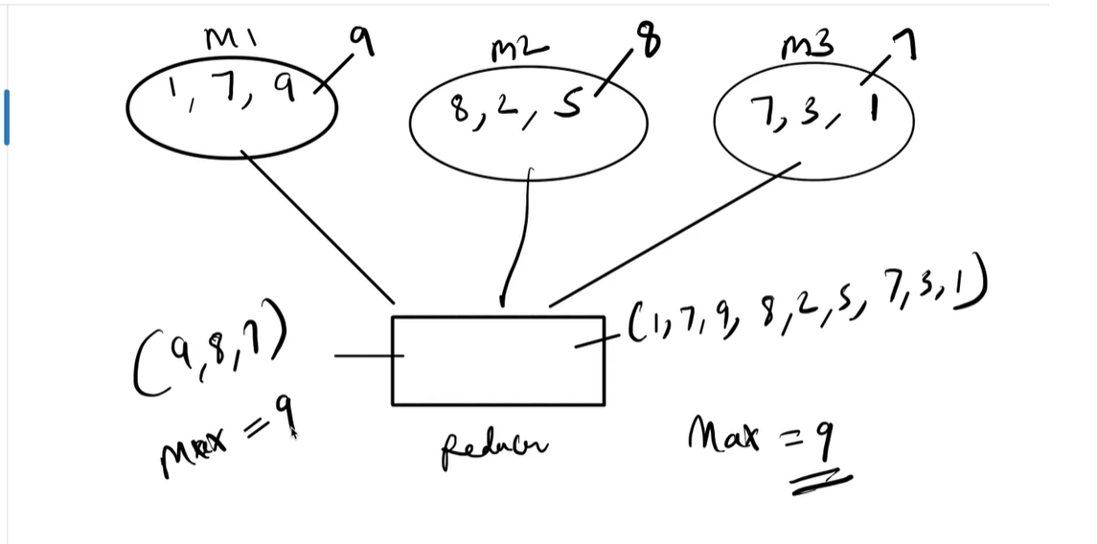

This is same for max. Min and sum
Using combiner or w/o combiner the result will be the same.

Average w/o combiner
M1 – 1, 3, 5
M2 – 3, 7, 9
M3 – 4, 7, 8, 7
CORRECT Answer would be – 54 / 10 = 5.4

Average with combiner
M1 – 1, 3, 5 – 3.0
M2 – 3, 7, 9 – 19/3 = 6.33
M3 – 4, 7, 8, 7 – 26/4 = 6.5

Reducer = (3.0, 6.33, 6.5) = 15.83/3 = 5.2
CORRECT Answer would be – 54 / 10 = 5.4
So if we take sum and count from each mapper
M1 – 1, 3, 5 --------- (9, 3)
M2 – 3, 7, 9 --------------- (19, 3)
M3 – 4, 7, 8, 7 --------------- (26, 4)
Reducer = (54, 10) = 5.4
CORRECT Answer would be – 54 / 10 = 5.4

